Bulletin Board

Problem: The excitement of coming to new town and settling there can sometimes get overridden by the anxiety of not getting the proper guidance about finding the basic needs. If there is an app which can help getting familiarize with the locality beforehand can be much more helpful.

Being said that, I would like to propose an app --A Bulletin board-- where one can search for all the answers to his questions.

An app in which the newbie can post a question and/or find the answers to common questions answered by the locals to get him familiarize with the locality.

Also, this app can be useful for locals who can post ads to sell or buy stuffs or just to get some information about any topics. This app when used in a corporate company can be used to carry a discussion or brainstorming about any new technologies or any general topics.

Overall, this app can be helpful to get the answers to all the requirements.

Some use cases:

* If person searches for carpool to go from one place to another. It will search in the carpool category where other users might have posted ads for carpools.
* If someone looking to buy a TV/electronics items and need suggestions on which model to buy or where to buy: he can post this query to Electronics category which can be answered by other users.
* Someone can post an add to sell any stuffs which can be seen by everyone.
* Someone wanting to post a confession? This app can be helpful to post a unanimous confession on its confession page.
* Looking for household fix (plumber, electricians, etc.)? The household category in app will help where user can post an ad for it.
* Looking for a best doctor in town. One can ask for suggestion in general category.

This app will have certain categories where related topics will be addressed as below.

* Carpool category: user can find, and post ads related to carpools.
* Electronics category: user can find, and post ads related to selling /buying of electronics equipment.
* Household category: user can find and post all household related topics like ad related to “need of an electrician” or “want to buy furniture”.
* Blogs category: can find and post blogs or any interested topics.
* Events category: can find topics related to upcoming events.
* Travel category: can find/buy sell of tickets.

What is used to built app?

App is built using swift 4 and in Xcode 10 using storyboard for navigation and firebase to support backend system.

The controllers used in this project are:

1. TabBar controller
2. NavigationController
3. TableViewController
4. CollectionViewController
5. UIViewController

Features:

1. Ask question to nearby locals.
2. Look for particular category for specific topics
3. Send an Email to any colleague or any local
4. Chat box to get some quick help
5. Search and add questions
6. Are you familiarize?? Great!! Now help others with answering questions to newbie by adding answer feature.
7. Option to login with Facebook or Email

Functionalities:

1. User has to sign up and then get verified using email verification to login to the home screen
2. App uses location to sort the questions and topics based on locations.
3. User can choose categories to filter out the topics related to categories.
4. User can add questions. Search Questions.
5. User can add categories. Search Questions.
6. User can send email.
7. User can chat using chat Box.
8. User can update profiles.
9. User can add answer.

**Screenshots for Steps to follow:**

1. Login screen. 2.Home Screen 3.User Tab

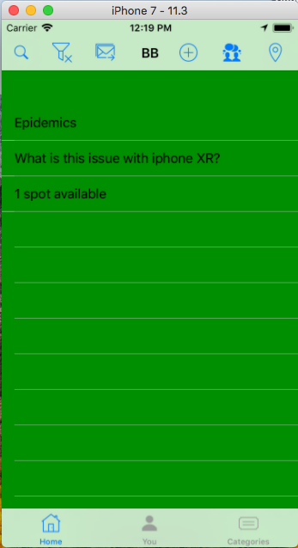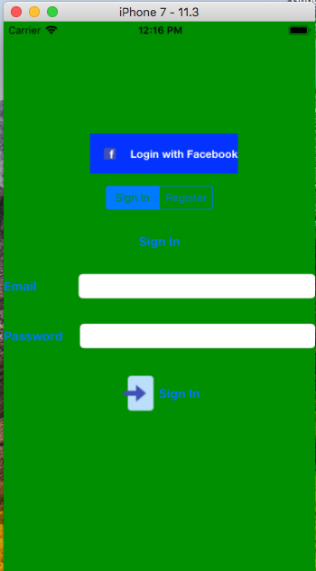

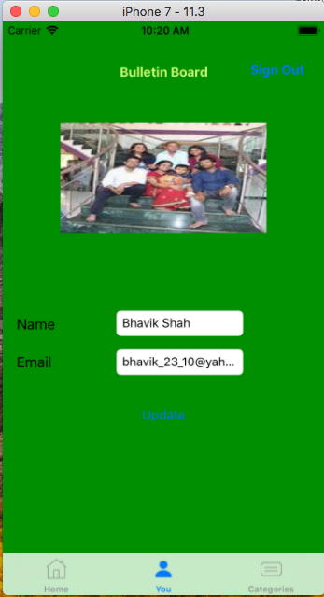

4. Category Tab 5. Add Question 6. Add Category

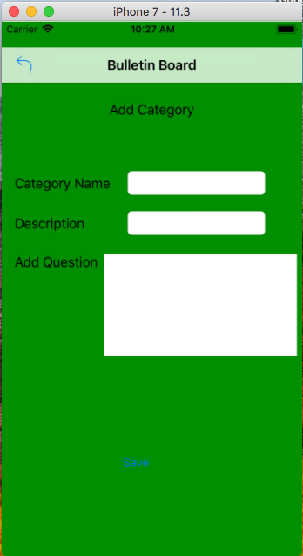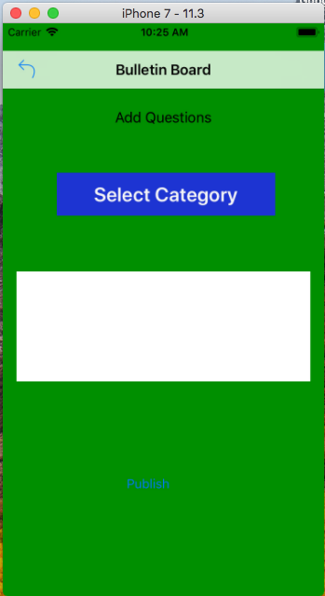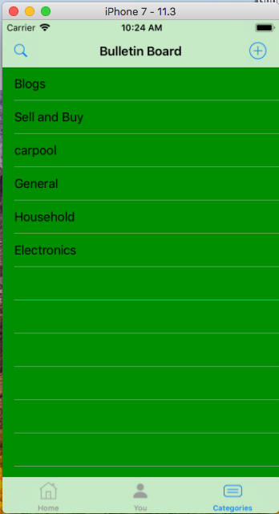

7.Update location alert 8.ChatBox Window

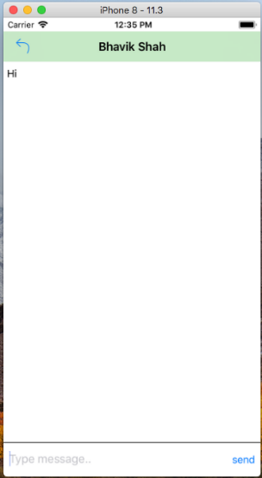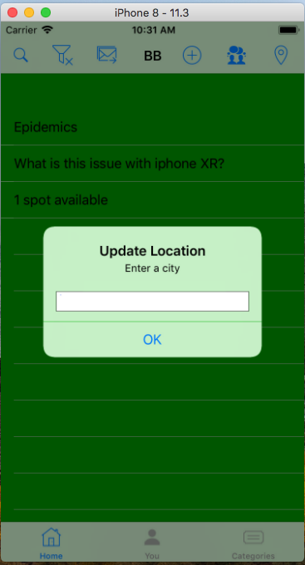

**Future Prospects:**

This is the core and basic level functionality implementation.

Some future prospects will be:

1. Better UI Design
2. Gmail Login
3. Bookmark category
4. Payment Gateway
5. User Default Constraints

**Conclusion:**

This app will solve an issue of anyone who is new to town/country to get settle down and connect with other locals and get familiarize with the town.